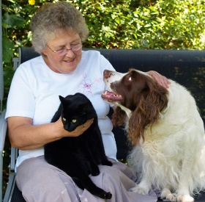
Pet Care
Services
Holly Hayes Pet Care Speicialist
Helping Seniors care for their pets in the comfort of their homes.
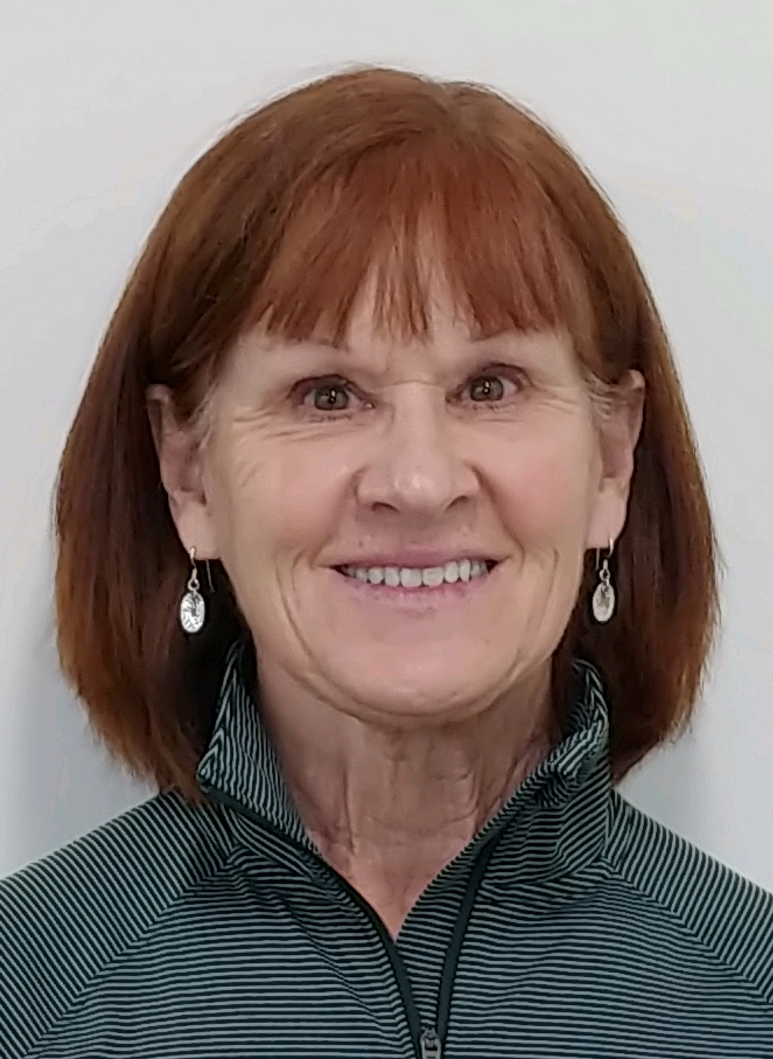
Services offered:
- Walking Dog
- Transportation of pet to Veterinary and Grooming appoints
- Pick up pet food and medications
- Administering of pet medication
- Clean litter boxes
- Other services may be available
Hours: Monday-Thursday 8:30 – 4:30
Minimum visit: 30 minutes
Charge: Current hourly rate
Call: Lonna at 259-3111 for scheduling.

