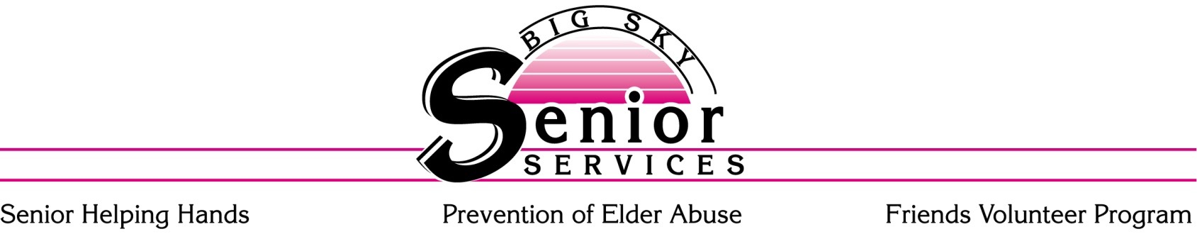

Thank you for your interest in our Senior Helping Hands program. Please complete the attached application and return it to Big Sky Senior Services, 935 Lake Elmo Dr., Ste. B, Billings, MT 59105. Once your application is received it will be reviewed and we will call you to schedule a meeting.
Senior Helping Hands is a program of Big Sky Senior Services, a private, nonprofit agency. Our goal is to help seniors remain living independently in their own homes by providing respite care, homemaking, personal care and nursing services.
Eligibility for Senior Helping Hands program is as follows:
- Currently living in Yellowstone, Stillwater or Carbon County
- Must be at least 60 years of age
- Have a diagnosed chronic health problem which prevents or restricts the client’s ability to perform chores or personal care
- Not eligible for similar services through Medicaid or Veterans Affairs.
- Living independently (assisted living or retirement homes are not eligible for services)
For more information about our programs, you can visit our website at www.bigskyseniorservices.org.
We look forward in assisting you. Please feel free to call Lonna at 259-3111 if you have any questions.
Thank you

Lonna Landon
Senior Helping Hands
Program Manager

935 Lake Elmo Dr., Ste. B Date Received _______________
Billings, MT 59105
(406) 259-3111 Client ID ___________________
FAX (406) 259-5839

Applicant Information

Name: ______________________________________________________ Phone#: ________-___________
(First name, Last name, middle initial) Cell #:_________-____________

Social Security #: ______-_____-_____ Date of Birth: _____/_____/_____Referred to by: ________________

Gender: □ MALE □ FEMALE Race/Ethnicity: □ Caucasian □ Native American □ Hispanic

□ African American □ Hawaiian/Pacific Island □ Asian □Other__________________________

Home Address: ___________________________________Apt # ________P.O. Box # ___________________

City: ________________________________, Montana. Zip: ______________County: ____________________

Name of Spouse: ________________________________ DOB_____/_____/_____ SS#______-____-_______

Emergency contact for client information or questions about care (ex. Spouse, family member, or friend).

Emergency
Contact Person:_____________________________________________ Relationship_______________________

Address:__________________________________________________ Phone #__________________________

City:______________________________St._________ Zip_________ Cell #____________________________

Email:_____________________________________________________ Work #___________________________

Additional contact person not living with client, (someone who has a key or access to home).

Contact Person:___________________________________________________ Relationship:________________

Address:________________________________________________________ Phone # ___________________

City:_______________________________St.:____________Zip:__________ Cell # _____________________

Email:__________________________________________________________ Work #_____________________

List all persons living in your home and their relationship i.e., self, husband, son, daughter, grandchild, nice, nephew, renter, etc.

1. _____________________________________________ Relationship: _____________________________

2. _____________________________________________ Relationship: _____________________________
Please use back of sheet to list additional people.
□ My bill will be paid by_____________________________.

Household Information

Housing: □ Own □ Rent Type: □ Home □ Apartment □ Trailer □Other ____________________

Please check all that apply
□ Elderly (over 62) | □ 1 – 4 Members living in Household
□ Female Head of Household (with dependents living in your home) | □ 5+ Members living in Household
□ Single | □ Disabled □ Veteran
□ I do not wish to furnish this information | □ Dog □ Cat □ Bird □ Other _______

Health Information

Health issues/concerns: ________________________________________________________________________

___________________________________________________________________________________________

Physicians Name: _____________________________________________________Phone # ______-________
Please list any additional physicians or specialists on the back

Pharmacy: ___________________________________________________________________________________

Other Specialists: _____________________________________________________Phone # ______-________

Is there a Providers Orders for Life-Sustaining Treatment (POLST) or Advanced Directive? □ YES □ NO
Check any programs you are currently enrolled in;

□ Meals on Wheels □ Food Stamps □ LIEAP □ Medicaid

□ Medicare □ Food Commodities □ other_____________________________________

Applicant Signature: _________________________________________________________ Date: _____________________

Hours of services: Monday – Friday 8:30 to 4:30
Please check the type of service you are requesting and frequency.

*Clients on a limited income may qualify for a cost sharing program which helps defray the hourly rate. If interested, please include proof of household income bank statement with this application.*

□ Homemaking Services
(Cleaning supplies must be provided by client)
Homemaking services needed:
□ Laundry □ Vacuuming/Floors □ Dusting □ Bathroom

□ Meal Preparation □ Grocery/Pharmacy Shopping □Kitchen/Dishes □Garbage

□ Weekly □ Every other week □ Monthly

Rate: $24/hour* (1 hr minimum)
□ Certified Nurse Aid
Personal Care services needed:
□ Bathing □ Hair Care □ Skin Care □ Assistance w/ dressing

□ Range of Motion Exercise

□ 1 X Week □ 2 X Week
Includes supervision and instruction during bathing to insure safety of client and staff at no charge.

Rate: $24/hour* (1/2 hr minimum)
□ Respite Care Services
Respite care is provided for caregivers of clients requiring supervision, including clients with Alzheimer’s. Respite care is delivered by a Homemaker or CNA depending upon the skills required during respite services. The Homemaker or CNA may provide homemaking and/or personal care while in the home.

Respite care is scheduled weekly, not to exceed 2 hours per visit, or 4 hours per week

□ Weekly □ Every other week □ Monthly

Rate: $24/hour* depending upon client care (1 hr minimum)
□ Registered Nurse
Registered Nurse services needed:
□Vital signs and brief review of systems
□Medication set-ups / pre-filling of insulin syringes
□Home safety and support systems assessment and client’s physician is notified of services
provided at no charge

□ Weekly □ Every other Week

Rate: $34/hour* (1/2 hr minimum)

